Creating a Cell Formatter Macro with Pop-up

Author: Muhammad Arif Bin Rawi

Date: 12 April 2020

# Preface

This guide assumes that you have already added the “developer” tab to your Excel tabs and that you have a basic understanding of Excel VBA. Ensure that you save the files as “macro-enabled” format (.xlsm). Also, as you will be working with VBA within work environment, you will need to know how to self-cert your macro.

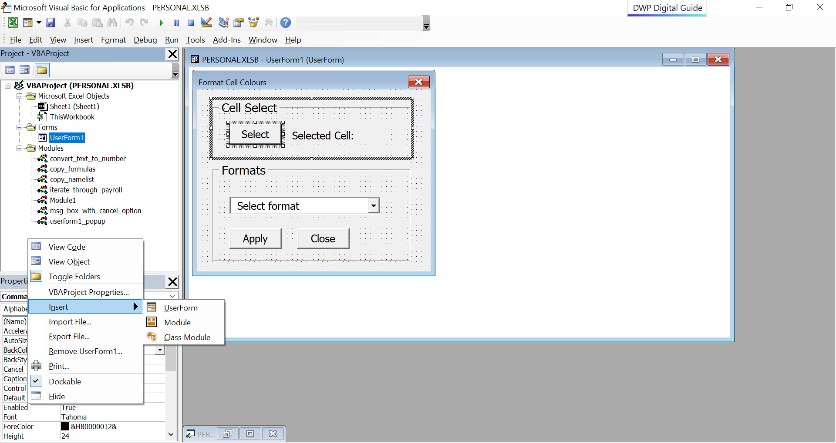

# The Interface

## Interface Layout

The interface is created using UserForm and is meant to be intuitive. At one glance, users should understand that they first have to select the cell they wish to start from. Then from there, select what kind of formats they wish to apply.

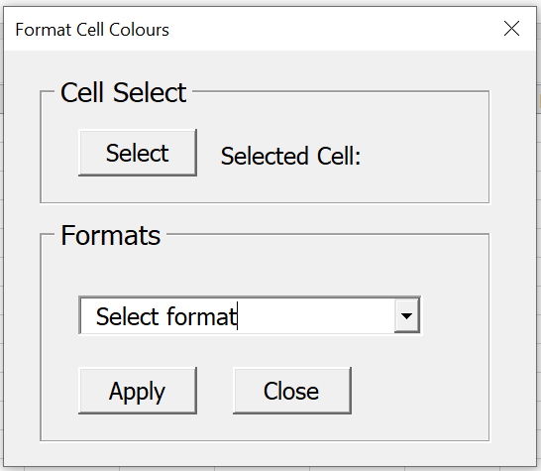

Clicking on the “Select” button will display a prompt that has a short instruction.

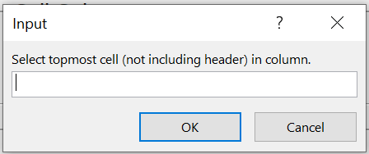

Clicking on the dropdown will show the formats available to apply.

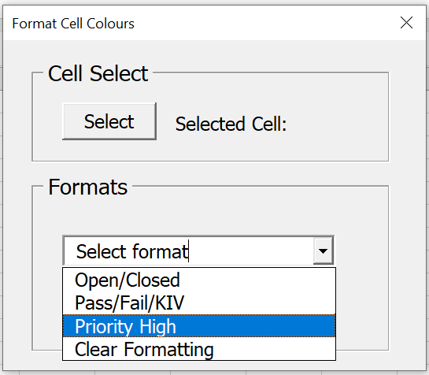

## Editing the interface

The font, size and label of the interface can be changed. For example, the “Select” button interface.



Click on the button and look at the properties window.

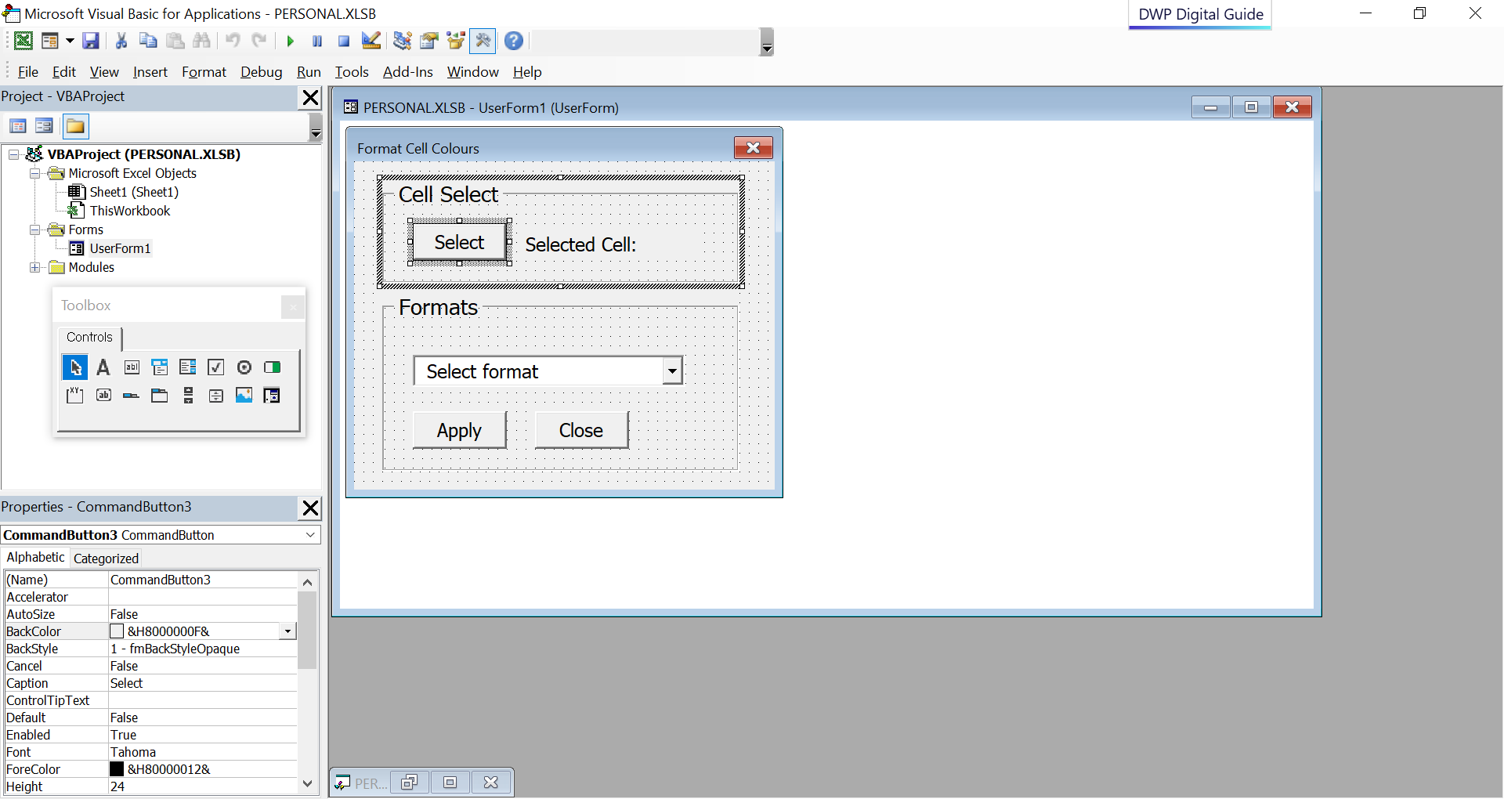

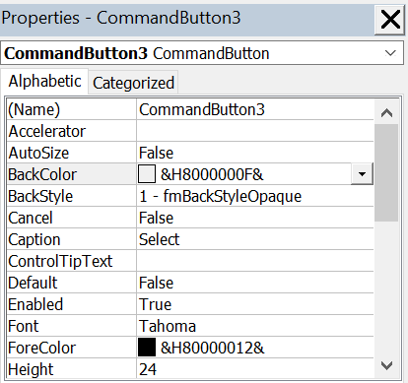

Either change this or directly edit the text from the button box to change the text.

This is the “variable” name. Change this to make it easier for you to reference in code.

You can change the height of the button here.

Click on this to change Font and text size.

## Interface Reference

Here are the Names given to the UserForm objects for easy reference to the code.



Label2

Label1

Frame1

ComboBox1

CommandButton1

CommandButton2

CommandButton3

Frame2

# The Macro

## Making the interface pop-up

Created a module that will make the UserForm pop-up by clicking on the macro button.

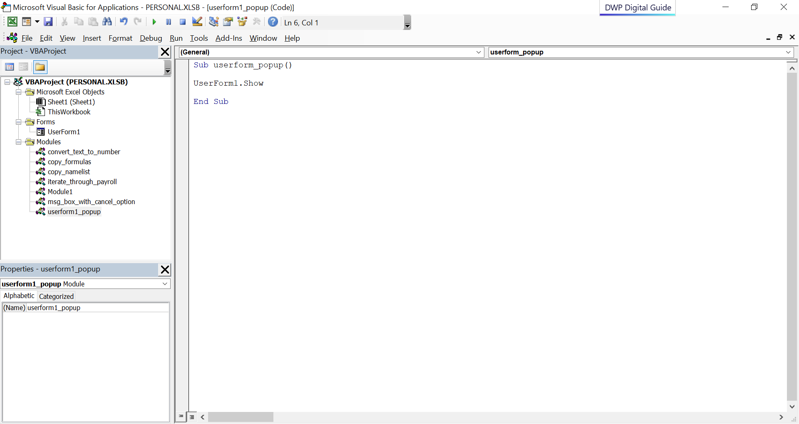

This in turn will allow the interface to come up.

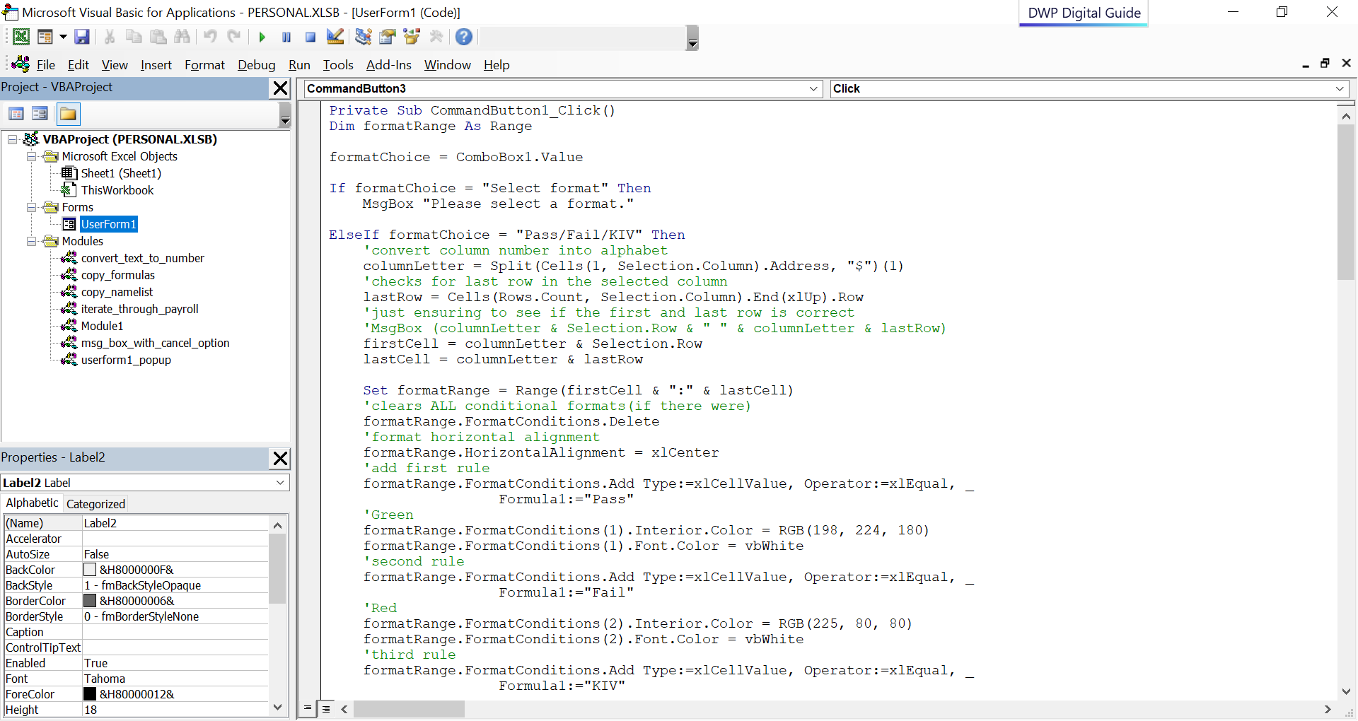

To look at the UserForm code, right click on the UserForm and select “View Code”.

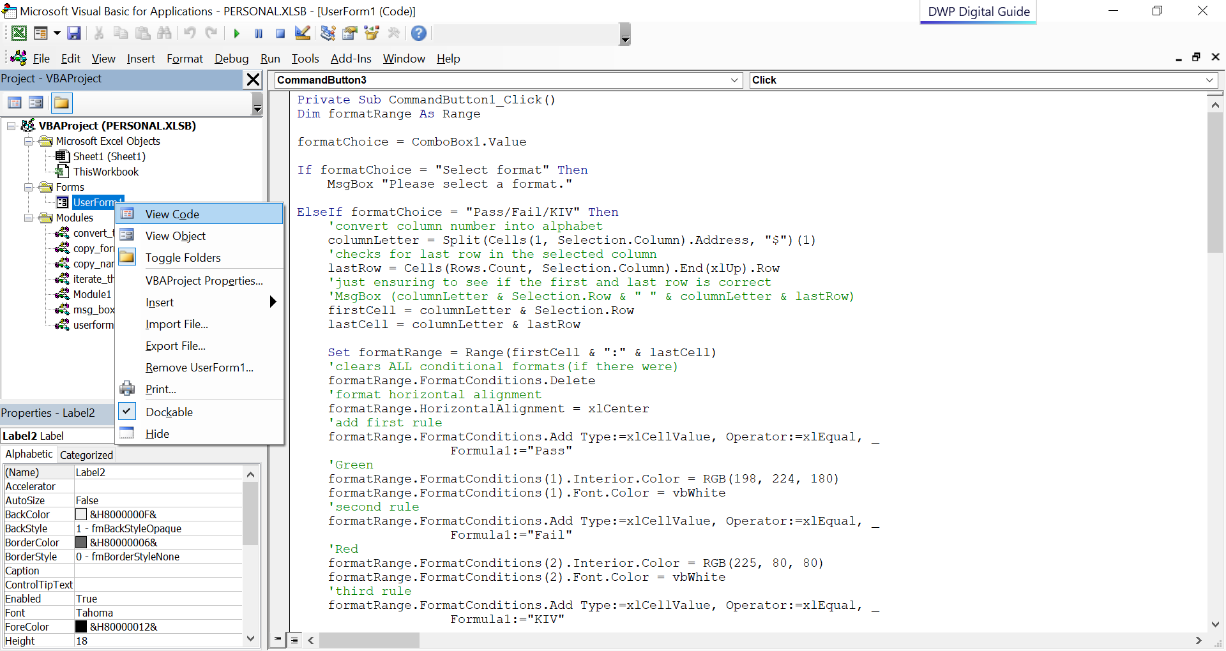

In order to get to the “Private Sub UserForm_Initialize()” portion of the code, click on the dropdown to look for “initialize”.

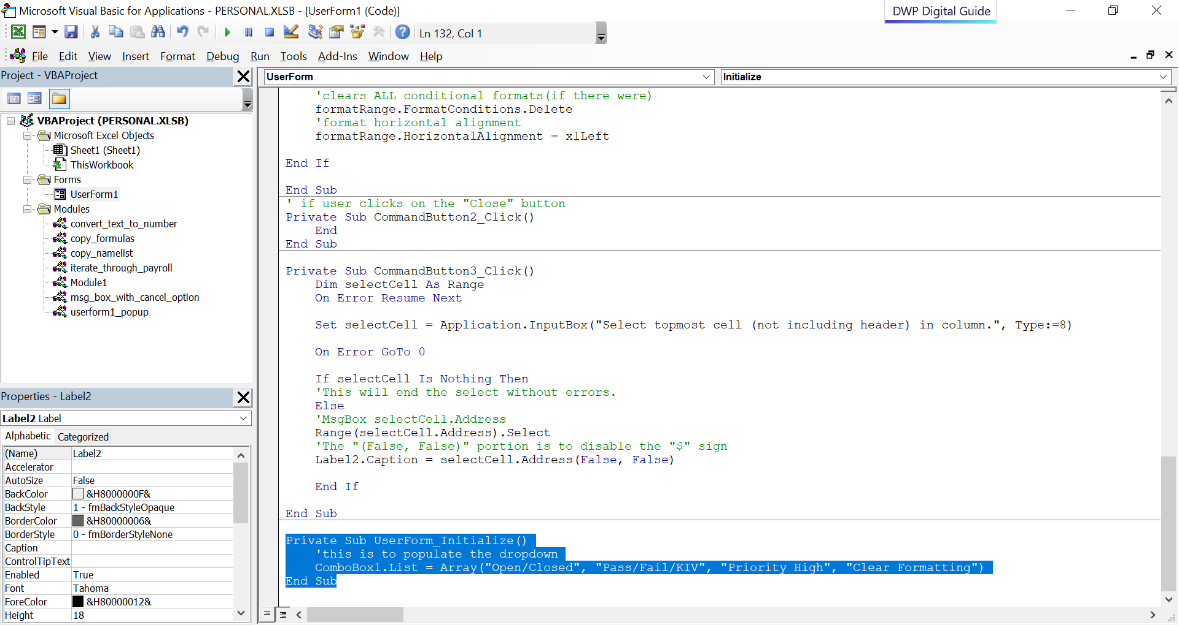

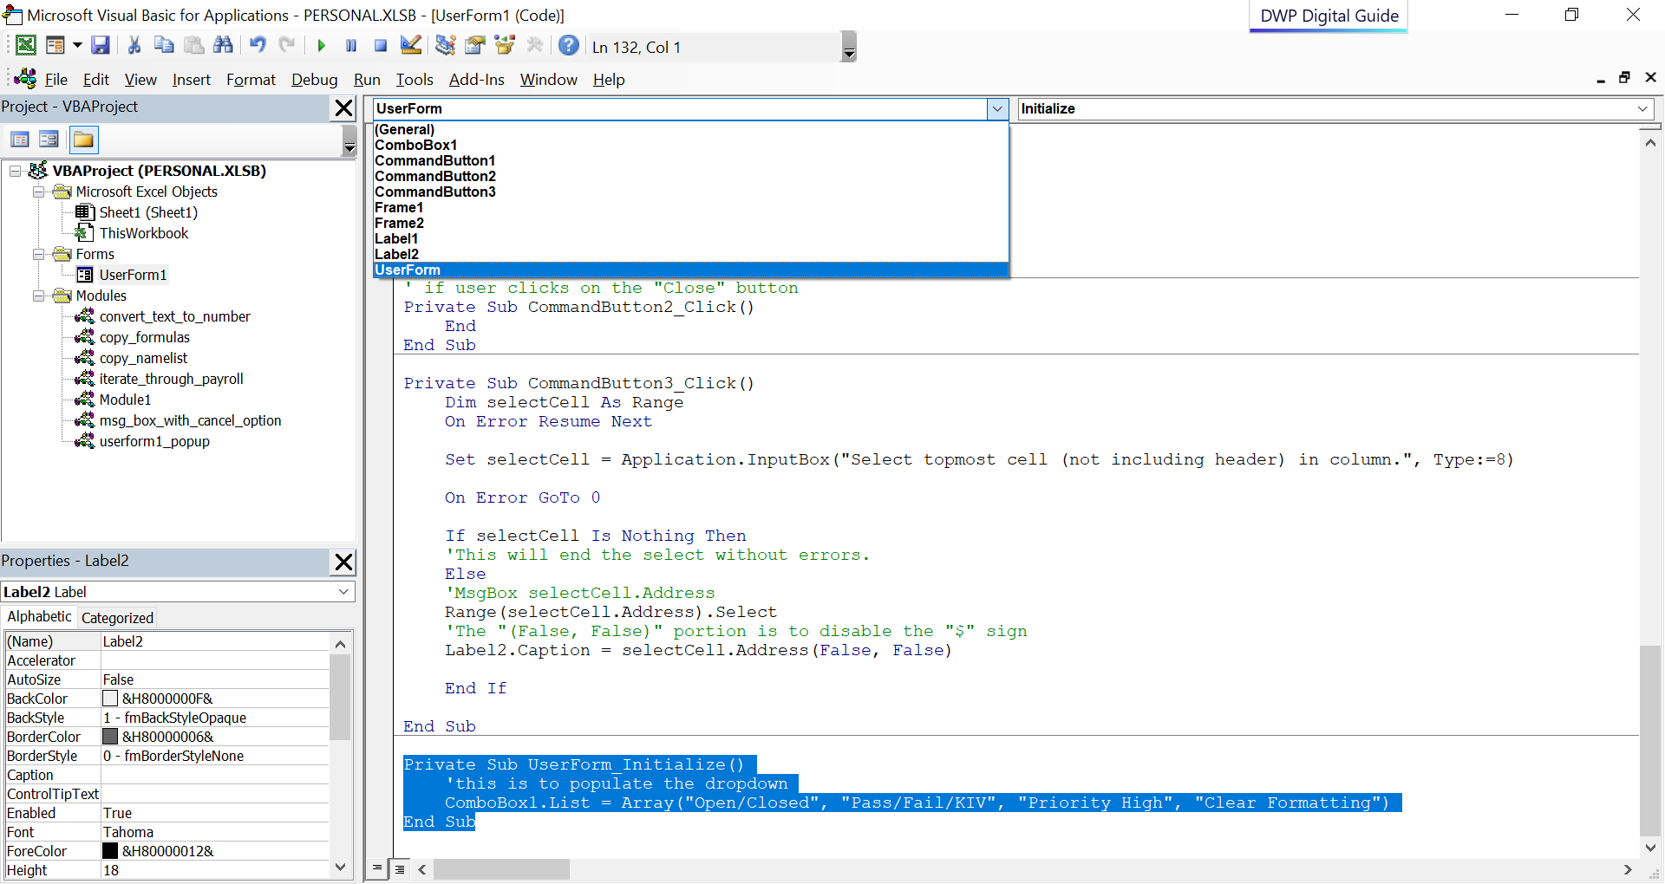

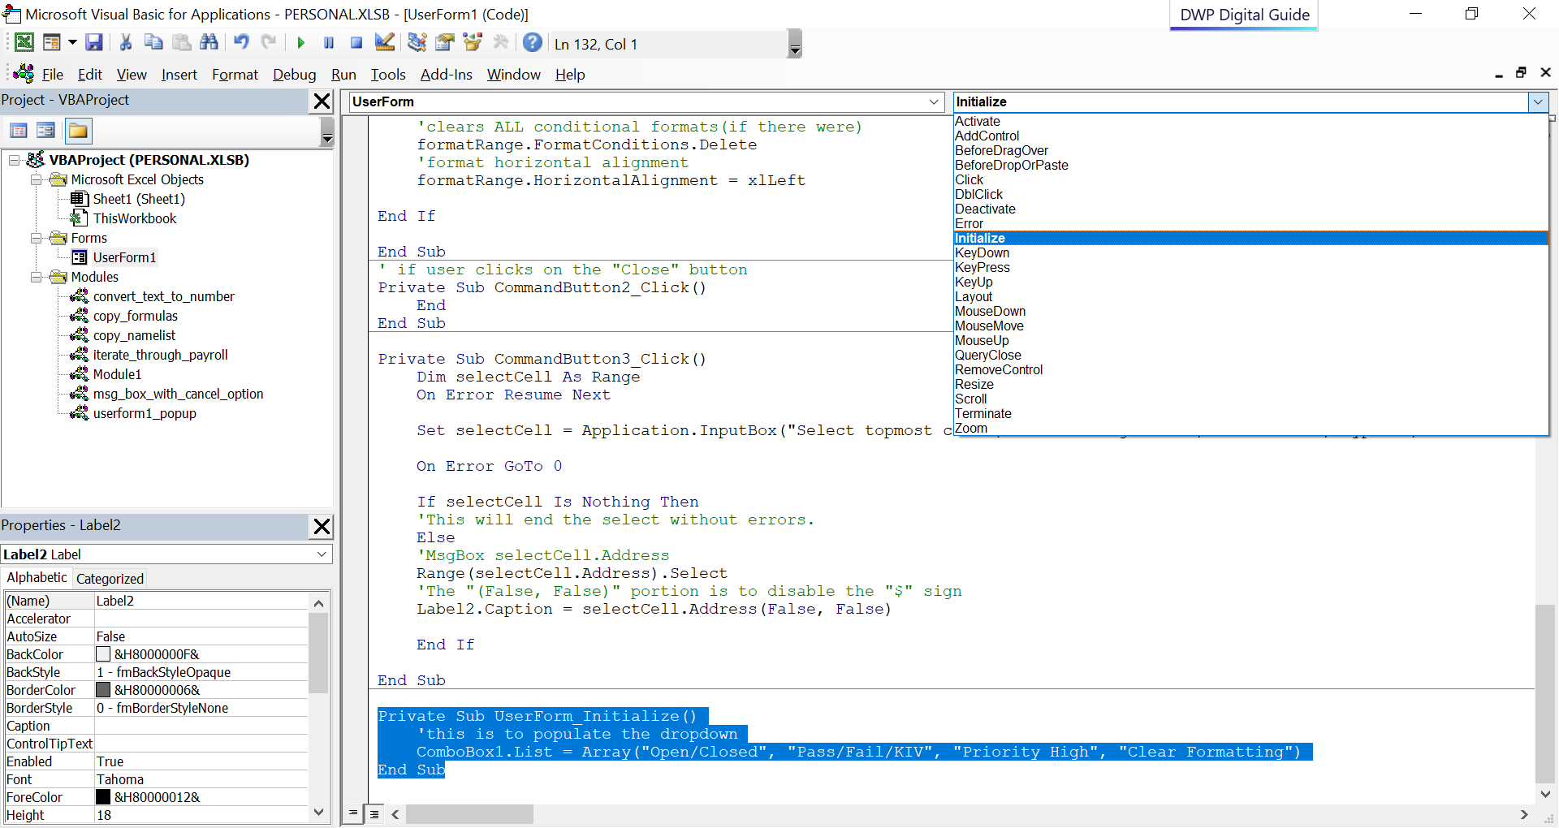

## Placing the Macro for usage

In order for the Macro to be used often, you can create a custom ribbon to be placed in the Tab.

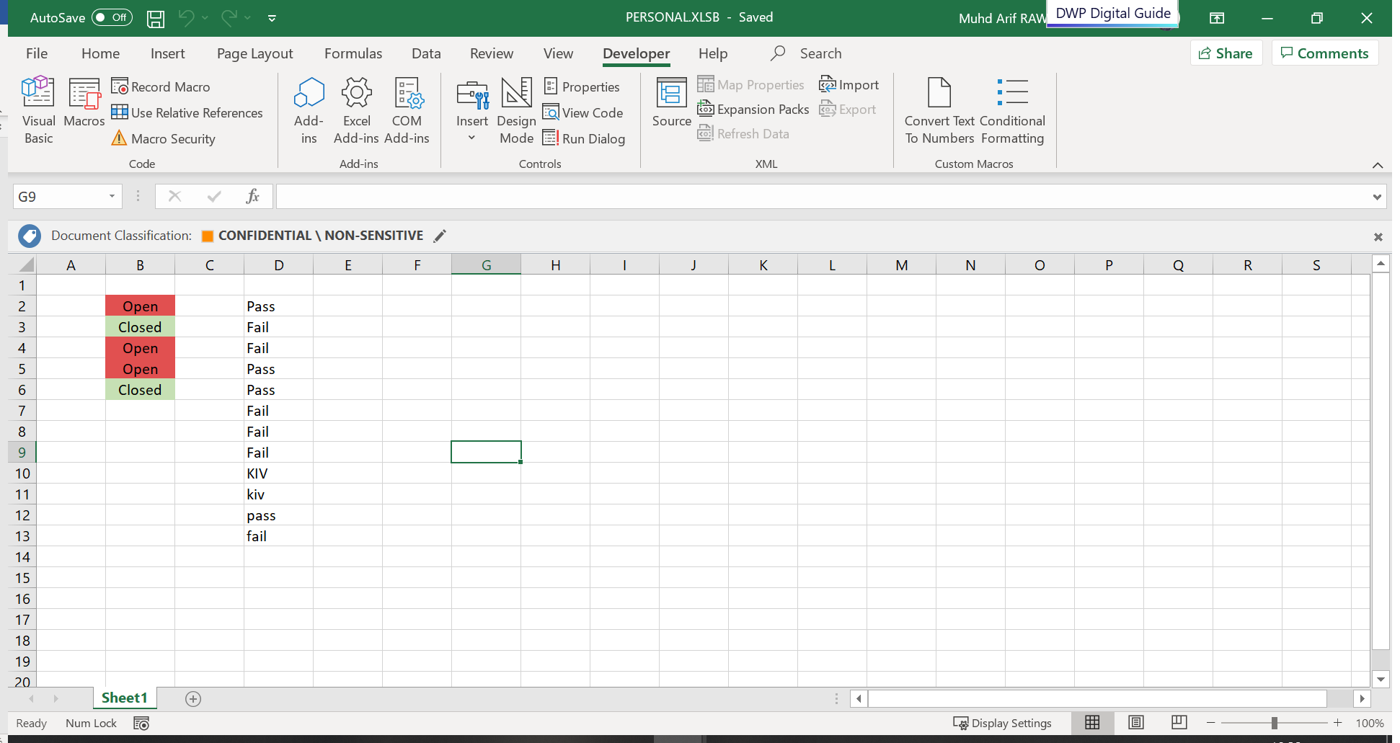

Go to File > Options > Customize Ribbon.

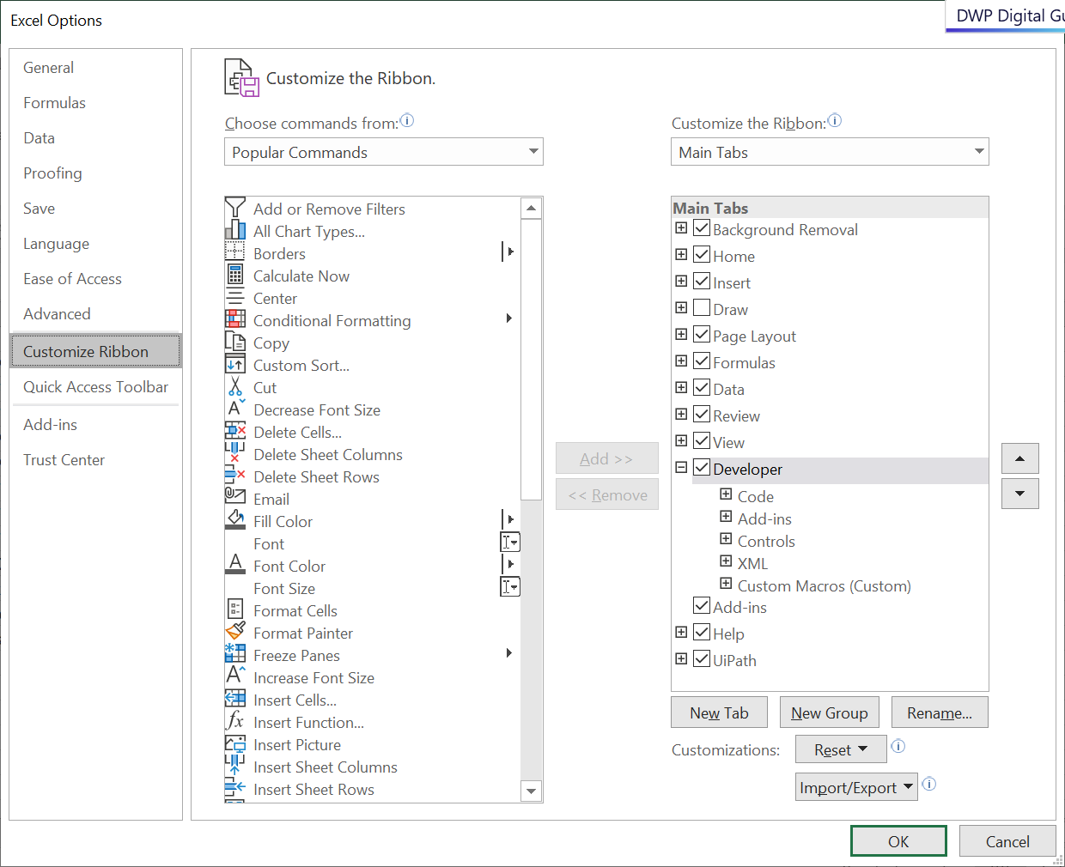

Click on Macros

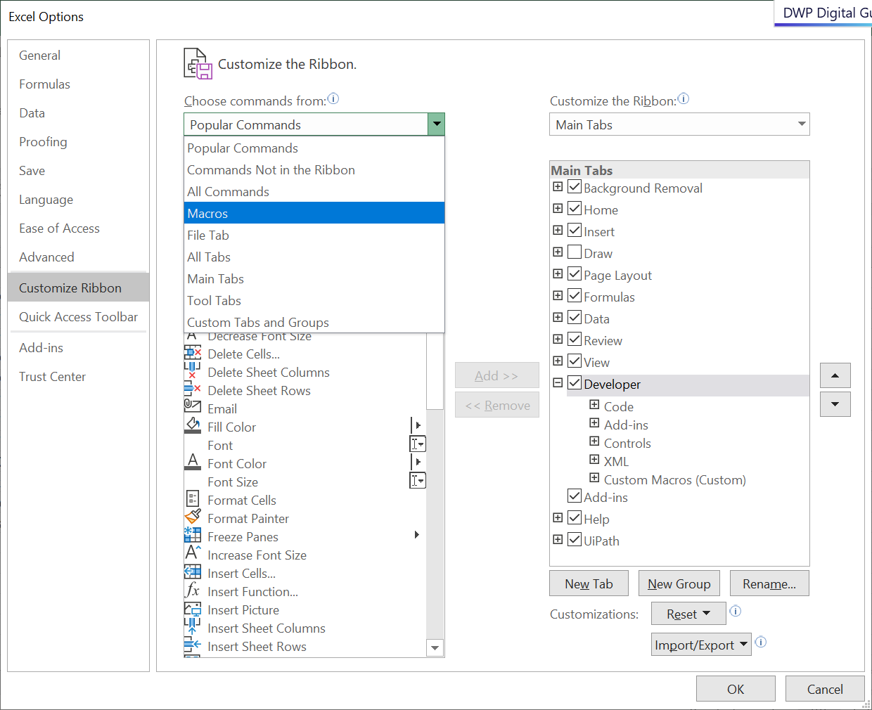

Click on “Developer” then “New Group”.

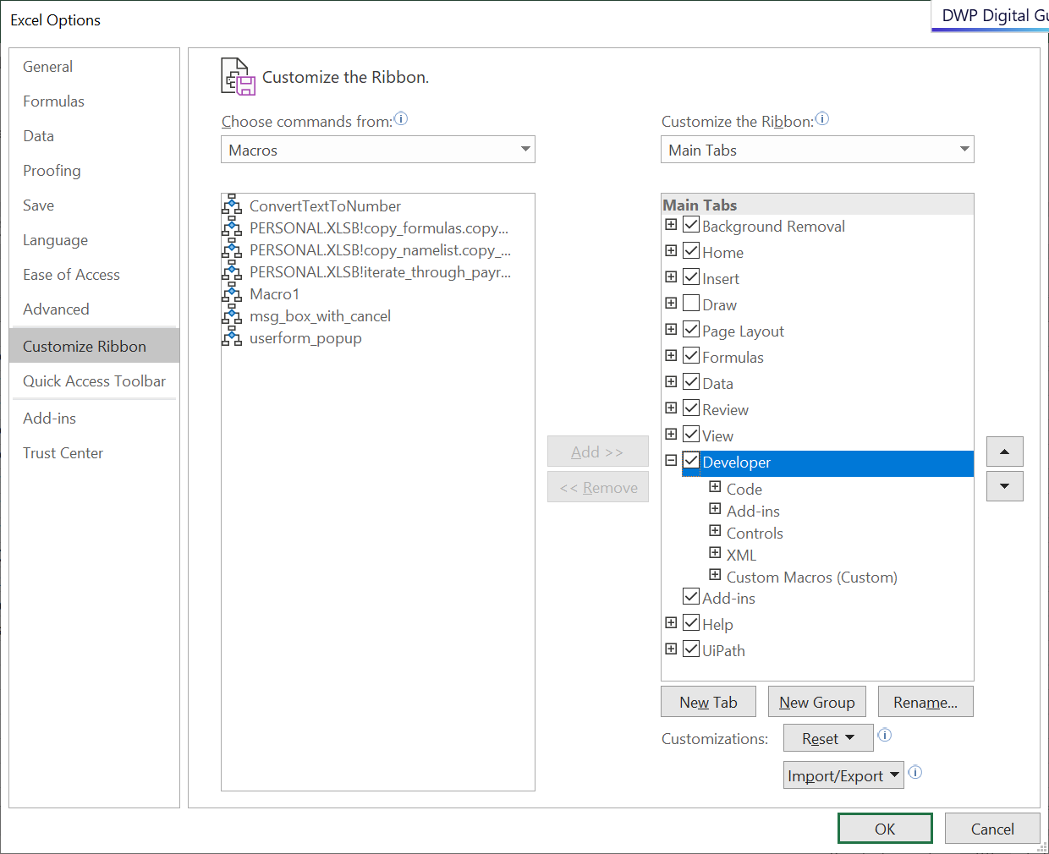

You can rename and even add an icon for it.

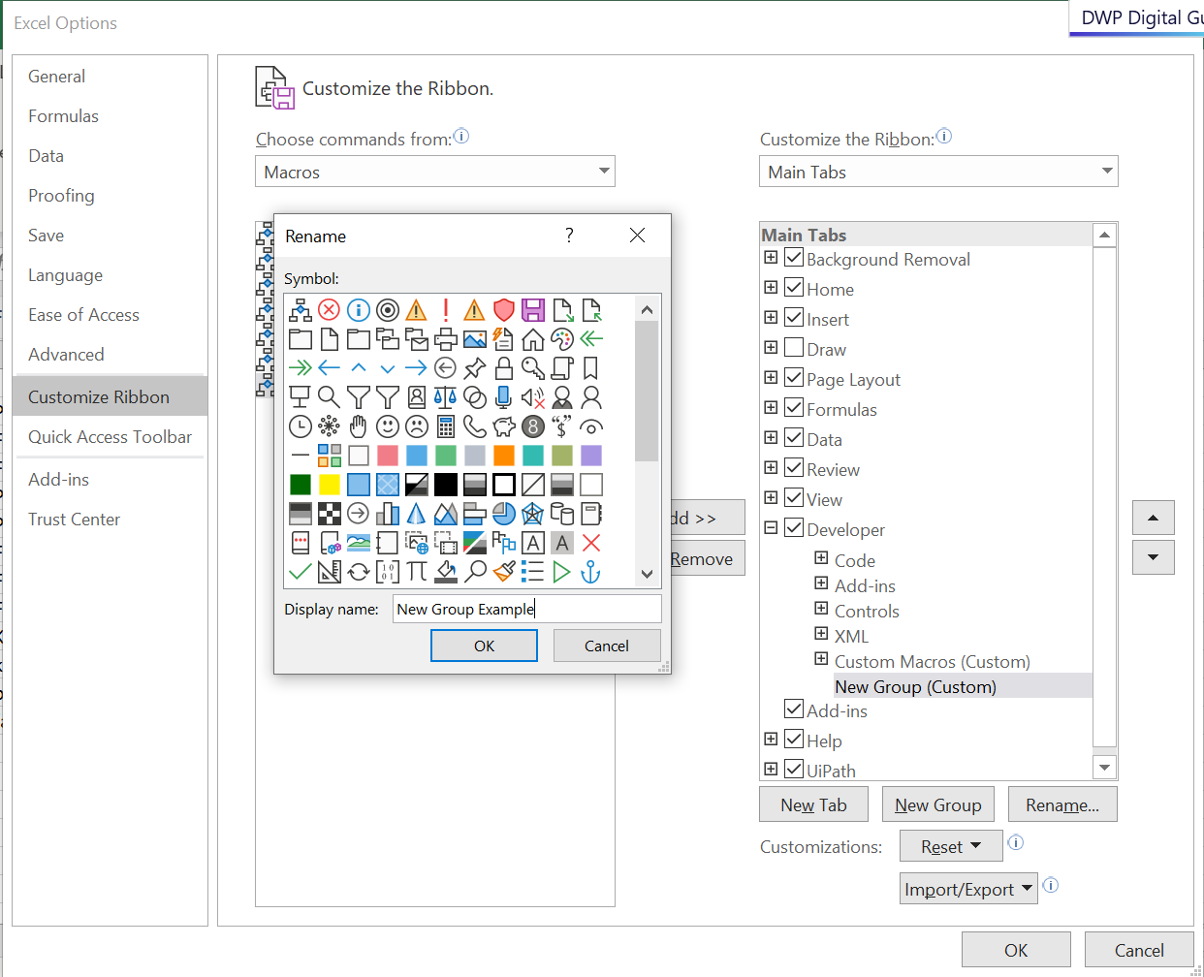

Select the Macro you wish to put in the new group. Ensure that you select both the macro and group you wish to move it into. The click on “Add >>”.

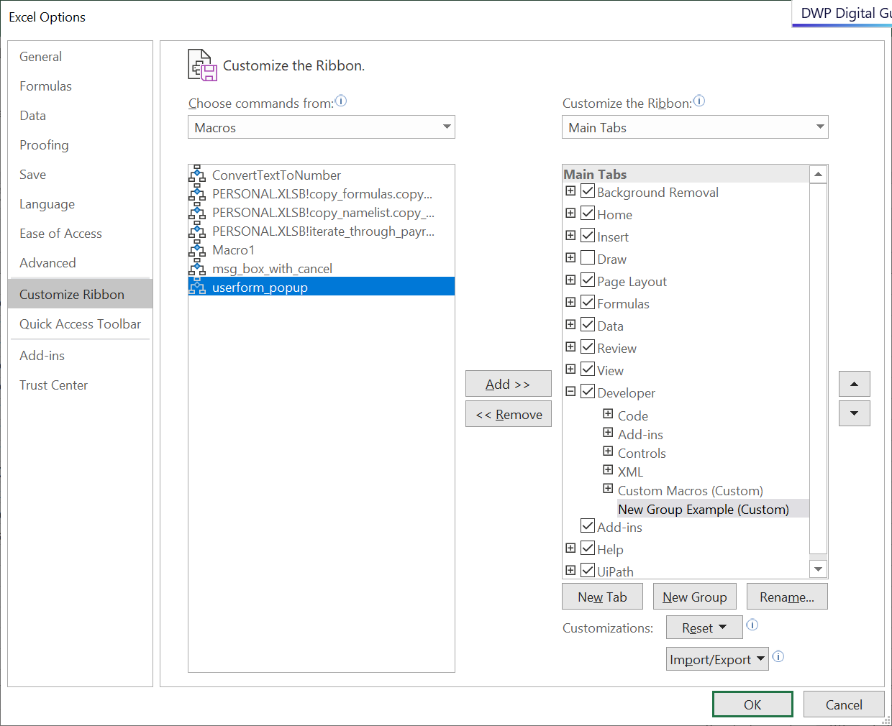

You can add icon and rename the Macro for easy reference.

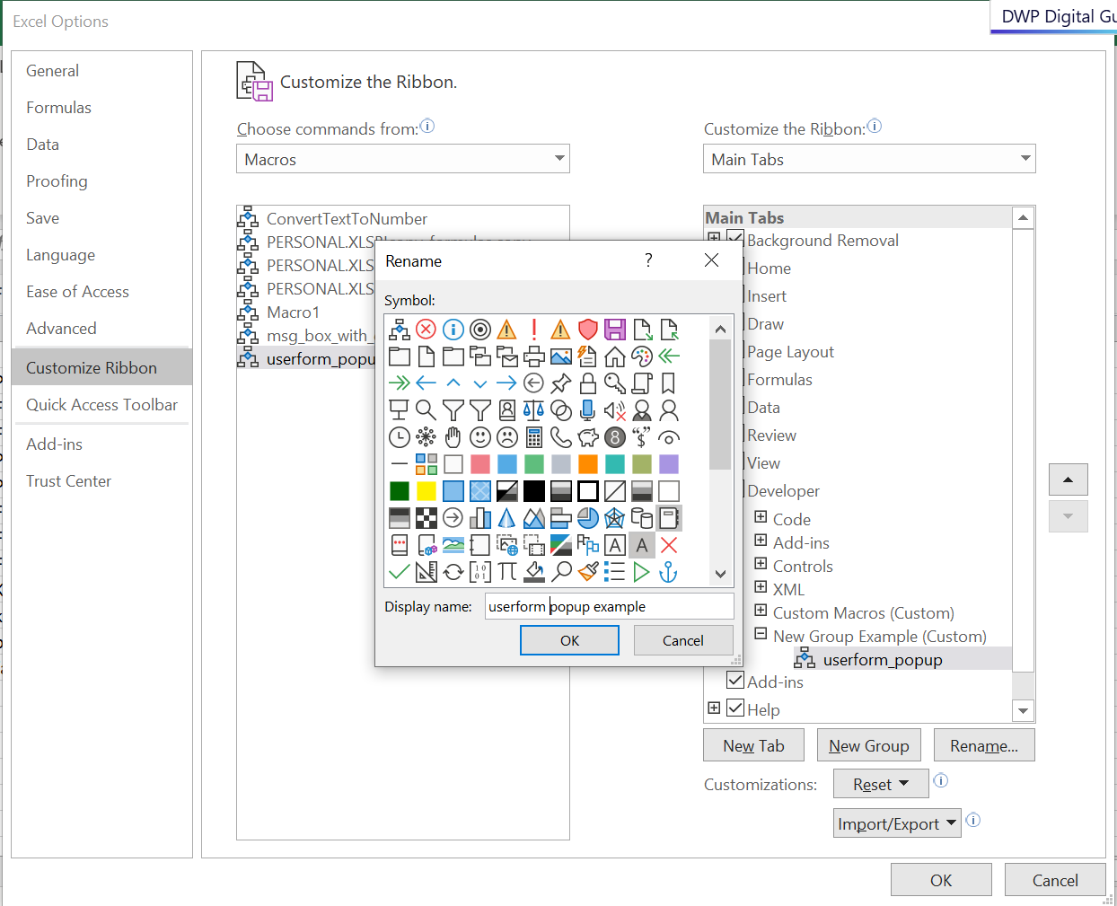

Click on “Okay” when you’re done. The new Macro should be in the new tab now.

